PROJECT TITLE

20.. – 20.. / …………. (Fall - Spring)
GRADUATION PROJECT
Advisor:
University ID - Name SURNAME

İstanbul, 20….

TABLE OF CONTENTS
Page
LIST OF FIGURES iii
LIST OF TABLES iv
ABSTRACT v
ÖZET vi
1. AIM AND NOVELTY……………………………………………………………………………………………1
2. INTRODUCTION 1
3. THEORETICAL INFORMATION 2
3.1 Guidelines 3
3.1.1 Example Title 3 3
3.1.1.1 Example Title 4 3
3.2 Figures 3
3.3 Tables 4
3.4 Equations 5
3.5 Representation of References in Main Text 5
3.6 Bibliography Guidelines 6
4. EXPERIMENTAL 9
4.1 Equipment and Materials 9
4.2 Experimental Study 9
4.3 Experimental Results 9
5. RESULTS AND DISCUSSION 10
6. PROJECT IMPACTS ON TODAY'S ISSUES SUCH AS HEALTH, ENVIRONMENT,
AND SECURITY ON UNIVERSAL AND SOCIAL DIMENSIONS................................11
7. FUTURE WORK……………………………………………………………………………………………………..12
REFERENCES 13
APPENDIX.1 EXAMPLE APPENDIX 124
APPENDIX.2 EXAMPLE APPENDIX 135

LIST OF FIGURES
Page
Figure 2.1 Landscape of Yıldız Technical University 4
Figure 3.1 Example Figure 2 9

LIST OF TABLES
Page
Table 2.1 Example Table 5
Table 3.1 Example Table 2 9

ABSTRACT
THESIS TITLE

1st Author Name Surname, 2nd Author Name Surname, ………..

Advisor:

The abstract of the thesis in English should be included in the ABSTRACT title and the key words should be written at the end. Keywords, which define the subject, should be selected. "Keywords" should be written in bold.
Anahtar Kelimeler: Minimum 3, maximum 6 words.

ÖZET
TÜRKÇE TEZ ADI

1. Yazar Adı Soyadı, 2. Yazar Adı Soyadı, ………..

Danışman:

Turkish translation of the abstract.
Anahtar Kelimeler: Keywords should be written in Turkish.

AIM AND NOVELTY
In this section the aim and original value of the thesis, should be given.

INTRODUCTION
This section should contain information that prepares the reader for the topic.

THEORETICAL INFORMATION
In this section, the theoretical information and information obtained from the literature review should be given.

Guidelines
While writing the thesis, the following guidelines should be taken into consideration.
- Only one of the "Calibri" or "Times News Roman" fonts should be used in the entire thesis text.
- Thesis titles (including subheading titles) should be written in 12 pt. bold. It is beneficial to use styles such as Title 1, Title 2 to easily identify title numbers and create an automatic table of contents.
- The main section headings of the thesis text (Title 1) should begin at the beginning of a new page.
- Section and subsection headings of the thesis text should be numbered.
- The main section headings of the thesis text should be in capital letters, and for the subsection headings the first letter of each word should be capitalized. Subtitle numbering of the fifth and higher order should not be used.
- In the subsection headings, the words like "and, or, of," etc.. should be written in lowercase letters.
- One character after the punctuation marks must be left blank. Rows and paragraphs should start from the left side of the page.
- "Justify" attribute should be used for thesis main text.
- Dots should not be used after the last digit in subsection, figure, tables and other numbering.
- Definitions and theorems must be written in bold, the first letter is capitalized and the numbering guidelines must be followed. It should be ordered from the beginning of the line to the head of the first degree section.

Example Title 3

Example Title 4

Figures
Figure number and description should be written under the figures and should be centered. Figures should be consecutively numbered starting with the number of each main section and should start with 1.
Example: 9th figure of 3rd section should be written as “Figure 3.9”. After the figure description number, one character must be left blank, only the first letter of the initial word, the other words should be written in small letters. 6nk and 12 nk must be spacing before and after the description of figures. Figures taken from other sources should be cited at the end of the figure name. Mentioning of the figures in the text should be as follows.
Example: These steps, which can be divided into several operations and are interchangeable, are shown in Figure 2.3.
Example: These steps, which can be divided into several operations and are interchangeable (Figure 2.3).
Example: These steps (Figure 2.3). which can be divided into several operations and are interchangeable
Use figure headings by copying the heading text of Figure 2.1 for automatic numbering for each chapter. MS Word will automatically number according to the section and order, if you paste it to the relevant figure, right click the numbers and update the field.
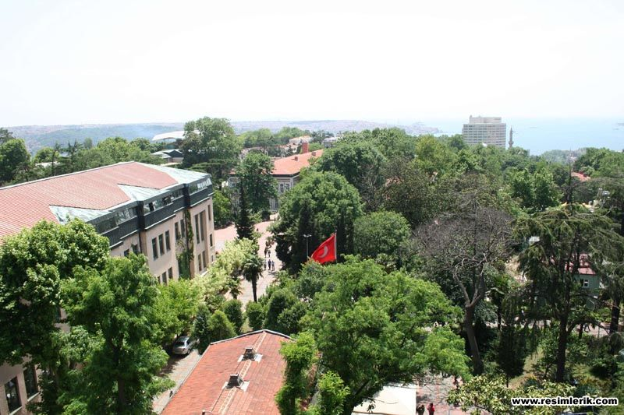
Figure 3.1 Landscape of Yıldız Technical University

Tables
Table number and description should be written over the tables and should be centered. Tables should be consecutively numbered starting with the number of each main section and should start with 1.
Example: 9th table of 3rd section should be written as “Table 3.9”. After the table description number, one character must be left blank, only the first letter of the initial word, the other words should be written in small letters. 12nk and 6 nk must be spacing before and after the description of tables. Tables taken from other sources should be cited at the end of the table name. Mentioning of the tables in the text should be as follows.
Example: These steps, which can be divided into several operations and are interchangeable, are shown in Table 2.3.
Example: These steps, which can be divided into several operations and are interchangeable (Table 2.3).
Example: These steps (Table 2.3). which can be divided into several operations and are interchangeable
Use table headings by copying the heading text of Table 2.1 for automatic numbering for each chapter. MS Word will automatically number according to the section and order, if you paste it to the relevant table, right click the numbers and update the field.
Table 3.1 Example Table
EXAMPLE | EXAMPLE
Experiment | 1

Equations
The equations should be written on the left side of the page. Equations must be consecutively numbered starting with the number of each main section then it should be numbered consecutively starting from "1" for each main section, this number should be written in parentheses, based on the right of the end of the line.
i.e. 14th equation of 2nd section, should be written as (2.14).
(2.1)
(2.2)
Between the text and the equation, before 12 nk space and after 6 nk space should be left. An equation in the text should be as follows.
Example With (2.21) equation nd multiplication can be calculated.

Representation of References in Main Text
Within the text, the references are indicated by writing the source number or by specifying the author surname and source number (IEEE reference style).
Example: In design, graphic design tools, decision table and structural narrative techniques can be used [1].
Example: A similar approach by Sauder and Westerman [2] is given by Kraft [3].
Example: According to Çelik [4], any internal ambient temperature can be calculated by the following formula.
Single Author: The author's surname and number will be shown indicating the source.
Example: (Boursier [5])
Two Authors: Between author surnames "and" should be placed.
Example: (Boursier and Mullon [5])
More than Two Authors: The abbreviation "et al." should be used after the first author's last name.
Example: (Ershun et al. [7])
Multiple References: References should be ordered by sequence number and "comma" should be used between them.
Example: [7], [9], [18]

Bibliography Guidelines
In the REFERENCES section, a reference list containing information similar to the following examples should be added.
Note: The references can be automatically generated according to the IEEE system by the following links:
https://www.refme.com/citation-generator/ieee/ veya
http://www.citationmachine.net/ieee
In addition, the reference list according to the IEEE system can be automatically added in References tab of MS Word. Using third party software such as Endnote, Mendeley, it is also possible to cite according to the IEEE system and create references list.
- Journal Article
[1] N. Surname1, N. Surname12 ve N. Surname13, “Article Title”, Journal Title, vol.volume no, no.Journal no, pp.pages, Year.
[1] J.P. Roth, “Diagnosis of Automata Failures: A Calculus and a Method”, IBM Journal of Research and Development, vol.10, no.1,pp. 278-291, 1966.
- Kitap
[1] N. Surname, Book Title, City: Publisher, Year
[1] H.A. Sidney, Introduction to Pyhsical Metallurgy, Second Edition, New York: Mc Graw-Hill Book Co., 1974.
- Thesis
[1] N. Surname, "Thesis Title", Thesis Type, Institute (Faculty or Department), City, Year.
[1] Gergün Seçil, "Representations of functions harmonic in the upper half-plane and their applications", Ph. D. thesis, Bilkent University Institute of Engineering and Science, Ankara, 2003.
- Meeting and Conference Presentations
[1] N. Surname, “Presentation Title”, Conference Title, City, if there is pp.pages, (Year).
[1] B. Küçükali, and L. Kandiller, "Deniz Harbinde Filo Konuşlandırma Problemi ve Akaryakıt Tüketim Simülasyonu", Savunma Teknolojileri Kongresi SAVTEK 2002, ODTÜ, Ankara, pp.263-271, (2002).
- Report
[1] N. Surname, “Report Title”, Publisher, City, (Year).
[1] A. S. Camtepe, S. Albayrak, ve B. Yener, "Optimally Increasing Secure Connectivity in Multihop Wireless Adhoc Networks" Rensselaer Polytechnic Institute, Department of Computer Science Technical Report TR-09-01, New York (2009).
- Standards
[1] Standard No, Standard Title, Prepared by, Press no, City, Year.
[1] ASTM 907, Standart Definitions of Terms Relation to Adhesives, ASTM, Philadelphia, 1982.
- Official Gazette (Law, Communiqué and Regulation)
[1] T.C. Official Gazette, law, regulation etc. Title. (no), pp. pages, Date.
[1] T.C. Resmi Gazete, Hububat Alımına İlişkin Kararın Yürürlüğe Konulması Hakkındaki Karar. (21242 mükerrer), pp. 2–10, 29.5.1992.
- URL References
[1] N. Surname, “Web Page Title,” [Accessed at: Gün Ayı Yıl].
[1] C.N. David ve G.H. Clifford, , A Criteria and Indicators Approach to Community Development, http://sfm-1.biology.ualberta.ca/english/pubs/PDF/WP_2002-2.pdf, (Accessed at; 21 Mart 2003).

EXPERIMENTAL
The equipment and raw materials used, experimental studies and experimental results should be given as subheadings in this section.

Equipment and Materials

Experimental Study

Experimental Results

Figure 4.1 Example Figure 2
Table 4.1 Example Table 2
EXAMPLE | EXAMPLE
Experiment | 1

RESULTS AND DISCUSSION
In this section, the results obtained from the thesis study should be written as clearly as possible. The comparison of results with previous studies should be discussed and the connection of the results to the theoretical basis must be clearly emphasized.
- PROJECT IMPACTS ON TODAY'S ISSUES SUCH AS HEALTH, ENVIRONMENT,
AND SECURITY ON UNIVERSAL AND SOCIAL DIMENSIONS.
In this section the outcome of the thesis should be discussed with regards to today’s issues.

- FUTURE WORK

REFERENCES
[1] J.P. Roth, “Diagnosis of Automata Failures: A Calculus and a Method”, IBM Journal of Research and Development, vol.10, no.1,pp. 278-291, 1966.
[2] H.A. Sidney, Introduction to Pyhsical Metallurgy, Second Edition, New York: Mc Graw-Hill Book Co., 1974.
[3] Gergün Seçil, "Representations of functions harmonic in the upper half-plane and their applications", Ph. D. thesis, Bilkent University Institute of Engineering and Science, Ankara, 2003.
[4] B. Küçükali, and L. Kandiller, "Deniz Harbinde Filo Konuşlandırma Problemi ve Akaryakıt Tüketim Simülasyonu", Savunma Teknolojileri Kongresi SAVTEK 2002, ODTÜ, Ankara, pp.263-271, (2002).
[5] A. S. Camtepe, S. Albayrak, and B. Yener, "Optimally Increasing Secure Connectivity in Multihop Wireless Adhoc Networks" Rensselaer Polytechnic Institute, Department of Computer Science Technical Report TR-09-01, New York, (2009).
[6] ASTM 907, Standart Definitions of Terms Relation to Adhesives, ASTM, Philadelphia, 1982.
[7] T.C. Official Gazzette, Hububat Alımına İlişkin Kararın Yürürlüğe Konulması Hakkındaki Karar. (21242 mükerrer), pp. 2–10, 29.5.1992.
[8] C.N. David ve G.H. Clifford, , A Criteria and Indicators Approach to Community Development, http://sfm-1.biology.ualberta.ca/english/pubs/PDF/WP_2002-2.pdf, (Accessed at; 21 Mart 2003).

APPENDIX.1 EXAMPLE APPENDIX

APPENDIX.2 EXAMPLE APPENDIX

